**AWS Cost Explorer**

**AWS Cost Explorer**

[**AWS Cost Explorer**](https://aws.amazon.com/aws-cost-management/aws-cost-explorer/) is a tool that enables you to visualize, understand, and manage your AWS costs and usage over time.

AWS Cost Explorer includes a default report of the costs and usage for your top five cost-accruing AWS services. You can apply custom filters and groups to analyze your data. For example, you can view resource usage at the hourly level.

**Example: AWS Cost Explorer**

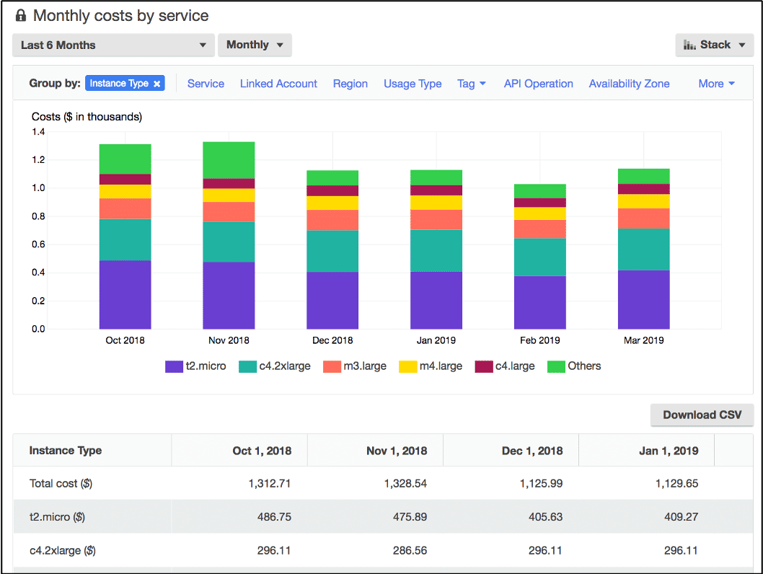

This example of the AWS Cost Explorer dashboard displays monthly costs for Amazon EC2 instances over a 6-month period. The bar for each month separates the costs for different Amazon EC2 instance types (such as t2.micro or m3.large).

By analyzing your AWS costs over time, you can make informed decisions about future costs and how to plan your budgets.